**MID – TERM III EXAMINATIONS, 2024**

**TOP CLASS – ORAL**

**My name is ...............................................................................................**

**I am in .......................................................................................................**

1. How many legs do you have? (5mks)

2. In which class are you? (5mks)

3. What is the colour of your uniform? (5mks)

4. How many legs does a hen have? (5mks)+

5. Mention **two** animals you know. (10mks)

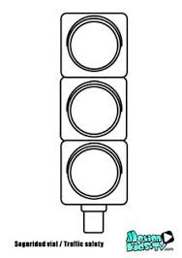6. Tell the road signs below.

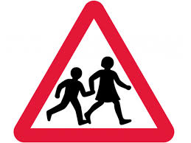

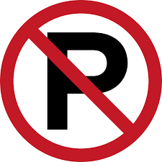

(5mks each)